Test Case: tc002_SPX_Dev5_Crear_Requisicion_Spot_Tipo_Cobro_Project
Step 1 - Enter username and password and click to button Enter: Credentials Entered
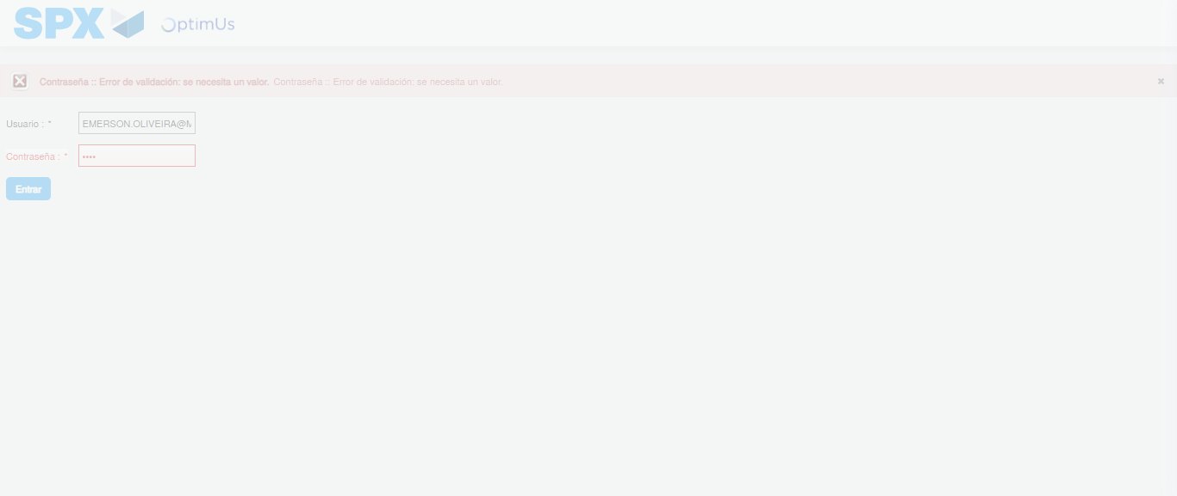Image file-name: QC_Testing-tc002_SPX_Dev5_Crear_Requisicion_Spot_Tipo_Cobro_Project-1785974130189

Step 2 - Select to UEN and Access to Spot Buy Requisitions : UEN Correctly selected and Correct access
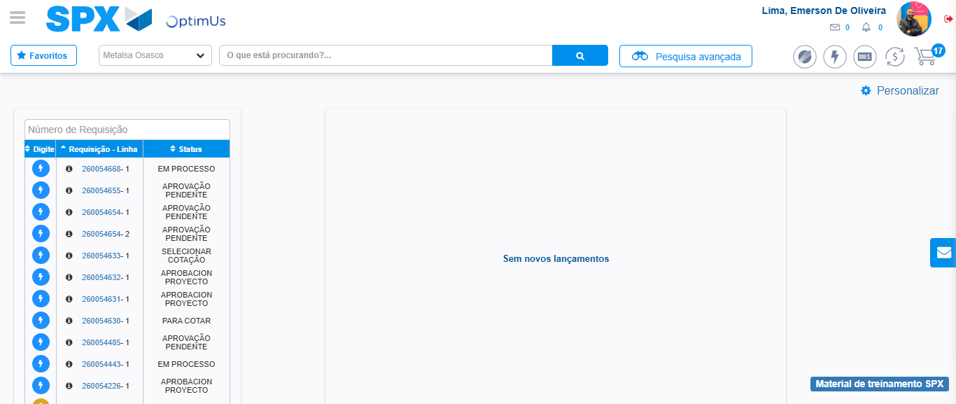Image file-name: QC_Testing-tc002_SPX_Dev5_Crear_Requisicion_Spot_Tipo_Cobro_Project-1785974154426

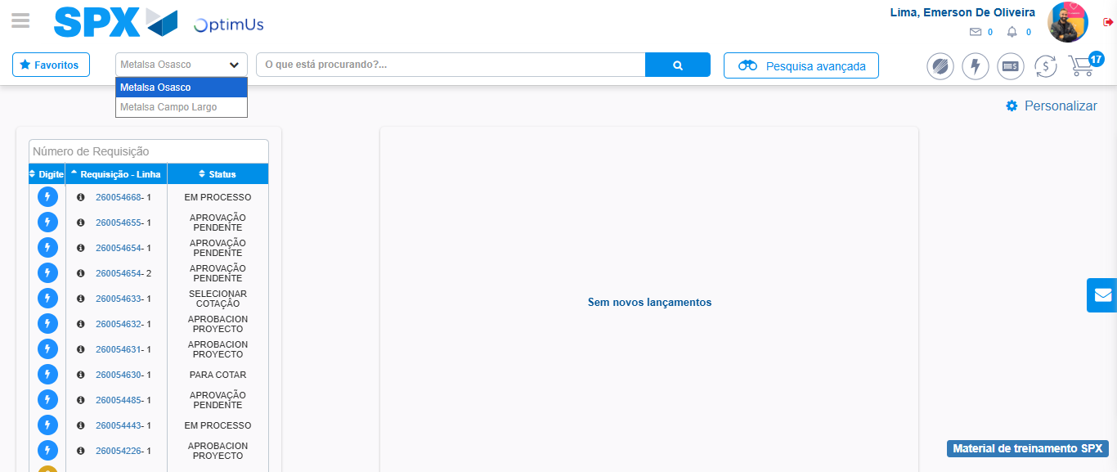Image file-name: QC_Testing-tc002_SPX_Dev5_Crear_Requisicion_Spot_Tipo_Cobro_Project-1785974157042

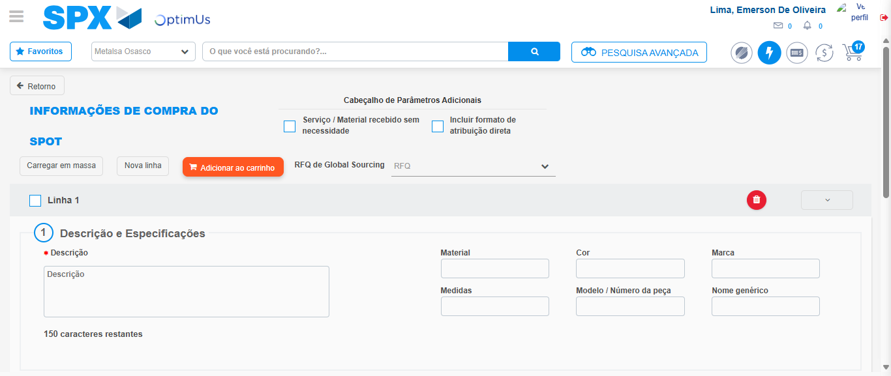Image file-name: QC_Testing-tc002_SPX_Dev5_Crear_Requisicion_Spot_Tipo_Cobro_Project-1785974161744

Step 3 - Data Capture Spot Buy Requisition: Data captured correctly
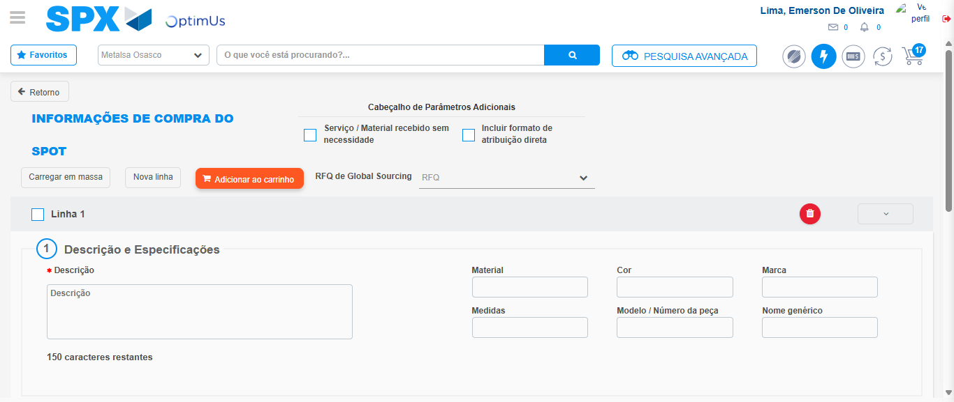Image file-name: QC_Testing-tc002_SPX_Dev5_Crear_Requisicion_Spot_Tipo_Cobro_Project-1785974162024

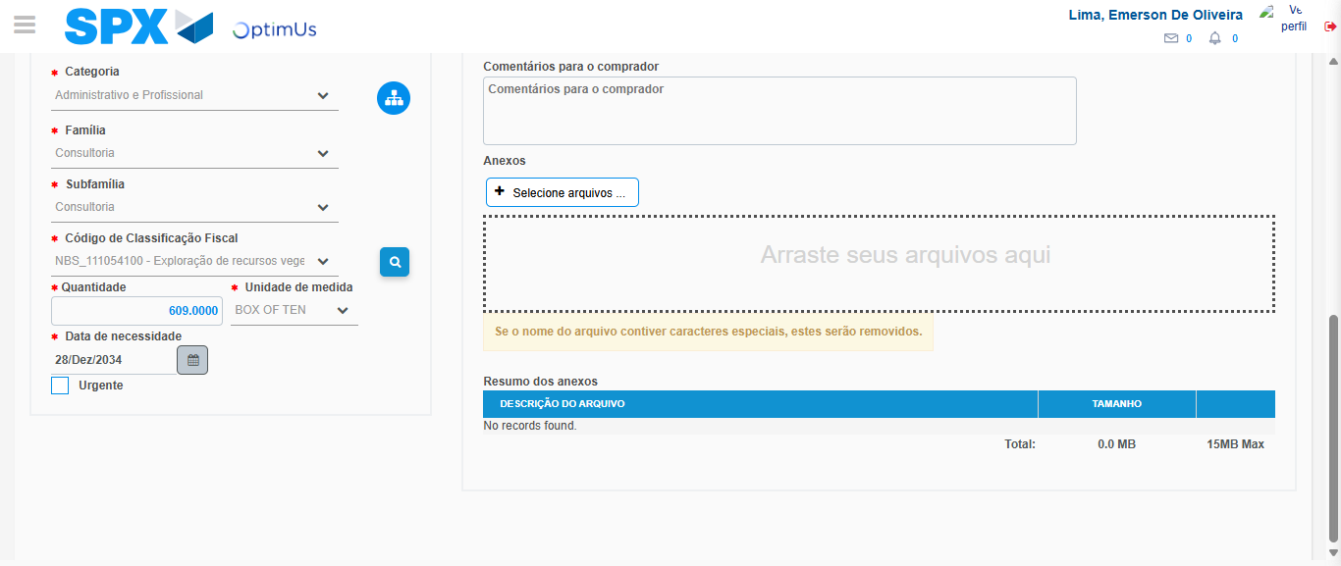Image file-name: QC_Testing-tc002_SPX_Dev5_Crear_Requisicion_Spot_Tipo_Cobro_Project-1785974178684

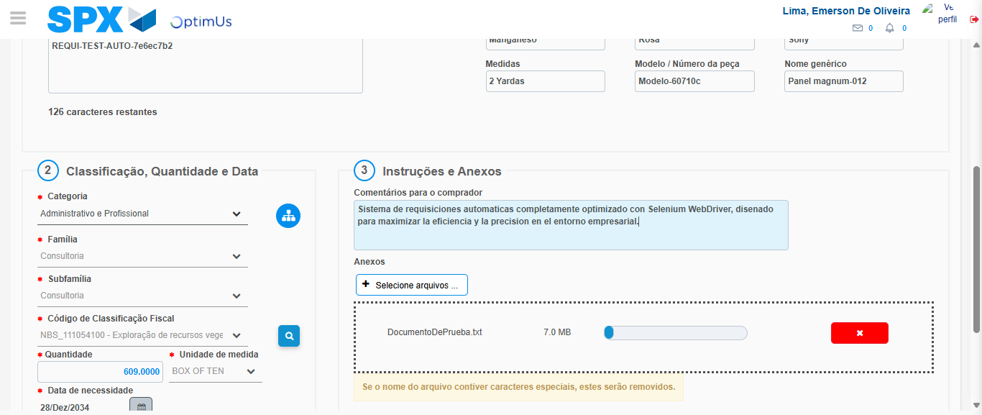Image file-name: QC_Testing-tc002_SPX_Dev5_Crear_Requisicion_Spot_Tipo_Cobro_Project-1785974179468

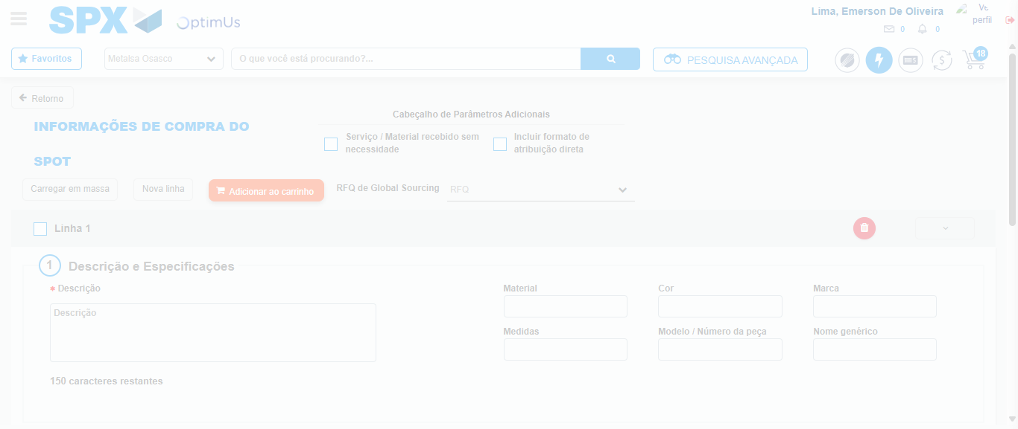Image file-name: QC_Testing-tc002_SPX_Dev5_Crear_Requisicion_Spot_Tipo_Cobro_Project-1785974180389

Step 7 - Return to Main Page SPX : Return to Main Page SPX
Image file-name: QC_Testing-tc002_SPX_Dev5_Crear_Requisicion_Spot_Tipo_Cobro_Project-1785974154426

Image file-name: QC_Testing-tc002_SPX_Dev5_Crear_Requisicion_Spot_Tipo_Cobro_Project-1785974157042

Image file-name: QC_Testing-tc002_SPX_Dev5_Crear_Requisicion_Spot_Tipo_Cobro_Project-1785974161744

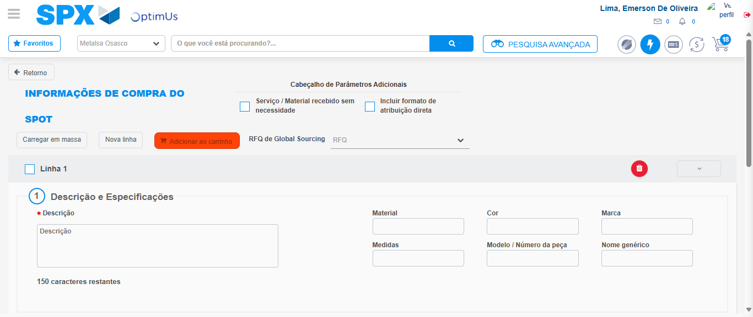Image file-name: QC_Testing-tc002_SPX_Dev5_Crear_Requisicion_Spot_Tipo_Cobro_Project-1785974182600

Image file-name: QC_Testing-tc002_SPX_Dev5_Crear_Requisicion_Spot_Tipo_Cobro_Project-1785974182776

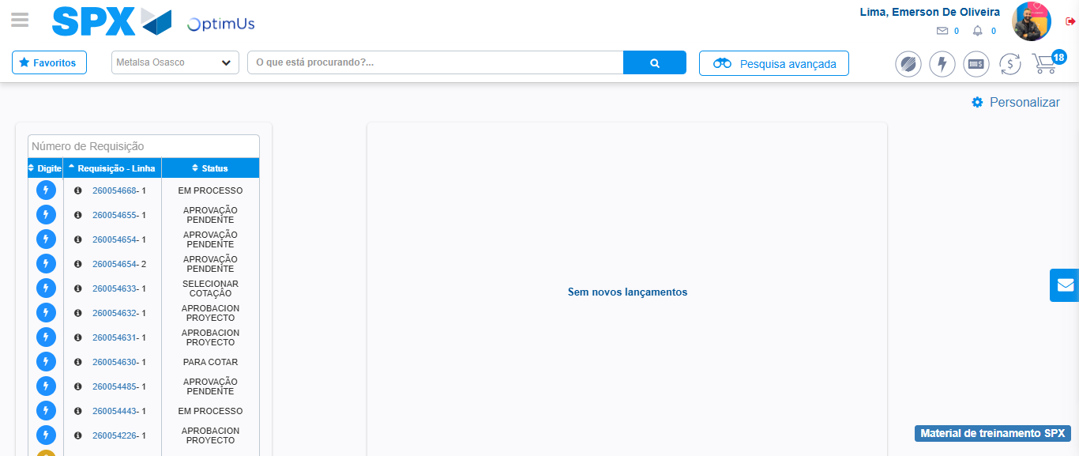Image file-name: QC_Testing-tc002_SPX_Dev5_Crear_Requisicion_Spot_Tipo_Cobro_Project-1785974203836

Step 8 - Log Out : Log Out SPX
Image file-name: QC_Testing-tc002_SPX_Dev5_Crear_Requisicion_Spot_Tipo_Cobro_Project-1785974204028

